Port 587 for SMTP

When you configure a mail client it’s necessary to set the right SMTP port to make the email delivery process work correctly.

The default port is port 25, but being so extensively used it also conveys a lot of malware and spam: thus more and more ISPs are filtering the emails coming through it, especially if they are sent with a different mail server. And among them, there can be yours.

The solution? Switch to port 587.

Port 587 is another SMTP submission port that’s supported by the vast majority of servers, and will definitely reduce the rate of rejected messages. That is particularly helpful if you’re sending bulk or mass emails (e.g. newsletters): in this case you should also get a dedicated SMTP server to maximize your deliverability and handle unlimited messages.

So how to change your settings from port 25 to port 587? You simply need to open your client’s configuration panel

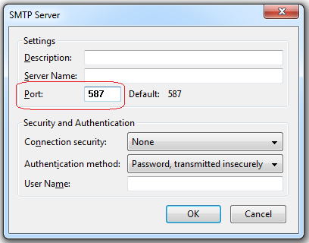

and type “587” in the “Port” section, as highlighted in the screenshot above. If you are experiencing issues with email delivery, this will surely help: your SMTP server will start connecting through port 587.

**So why should I use it?**

Whenever you’re given a choice, you should use 587 as the default SMTP port. It comes with TLS encryption and is the officially recognized port for email submission.

When 587 is unavailable or doesn’t work as expected, use port 2525 as an alternative. It has the same suite of features as 587 but has not been officially recognized.

For email relaying and relaying only, use port 25. Nothing has changed for the port since 1982, and it’s perfectly sufficient for these purposes.

Referral link:

<https://serversmtp.com/port-587/>